# PROJECT REPORT TEMPLATE

1. **INTRODUCTION**
   1. **Overview**

**CRM (Customer Relationship Management) that helps to book a visa slot.**

**A Visa slot management project is a system that is used to tract and manage the availability of visa slots, which are appointments that are required for certain visa applications. It might be used by a government agency or a visa processing centre to schedule and manage appointment with applicants.**

# Purpose

**Uses of crm helps to book a visa slot:**

* **Better customer service**
* **Increased booking of visa slots**
* **Improved customer retension**
* **Detailed analytics**
* **Managed communications with prospective leads**

1. **PROBLEM DEFINITIONS AND DESIGN THINKING**
   1. **Empathy Map**

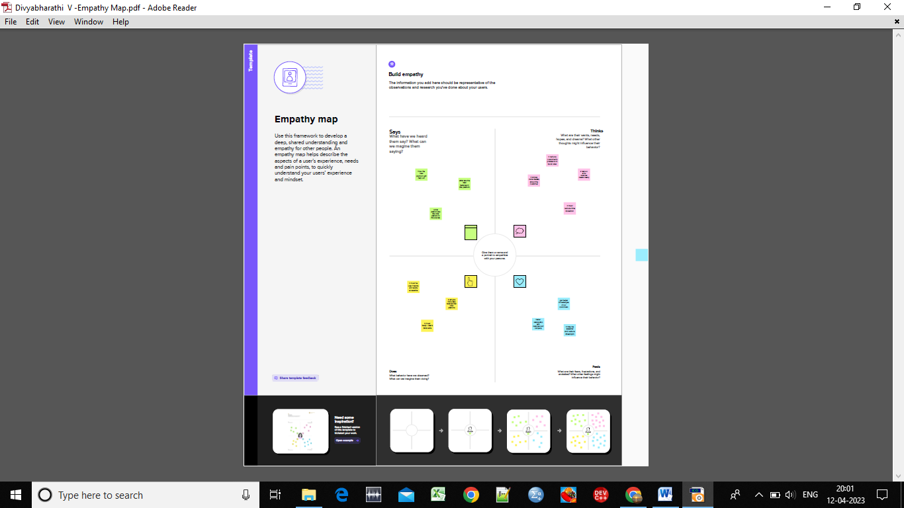

* 1. **Ideation & Brainstorming Map**

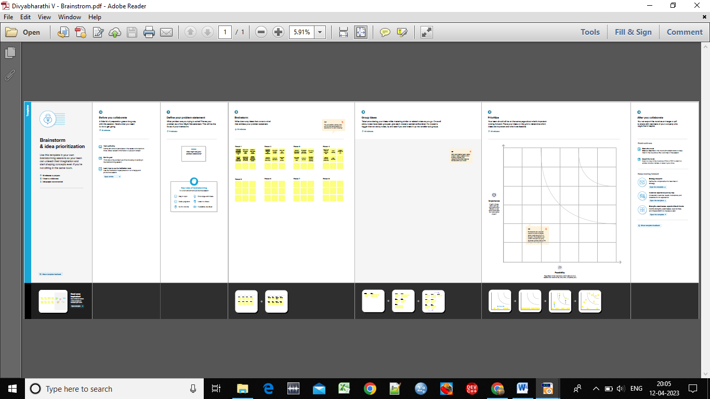

1. RESULT
   1. Data **Model**:

|  |  |
| --- | --- |
| **Object name** | **Fields in the Object** |
| 1. **Passport** | |  |  | | --- | --- | | **Field label** | **Data type** | | Full name | Text | | Passport number | Text | | Contact number | Number | | Permanent address | Text | |
| 1. **Visa slot** | |  |  | | --- | --- | | **Field label** | **Data type** | | Location | Geolocation | | Time | Time | | Passport number | Master detail relationship | | Visa slot number | Number | |
| 1. **Payment** | |  |  | | --- | --- | | **Field label** | **Data type** | | Payment mode | Text | | Card number | Text | | Transaction id | Auto number | | Cancel transaction | Text | | Visa slot number | Master detail relationship | |
| 1. **Reschedule/ cancel** | |  |  | | --- | --- | | **Field label** | **Data type** | | Passport number | Master detail relationship | | Location | Geolocation | | Time | Time | | Cancel | Text | | Status | Text | |

* 1. **Activity**  **& screenshot**

**Creation of custom object:**

1. **Navigate to setup , go to object manager and click create custom object.**
2. **Then we will navigate to the page where we can give object name and label name and plural label.**
3. **And we can select the data type as text,select deployed option.**
4. **Then click next we will select tab style and click save.**
5. **Thus we can create custom object.**

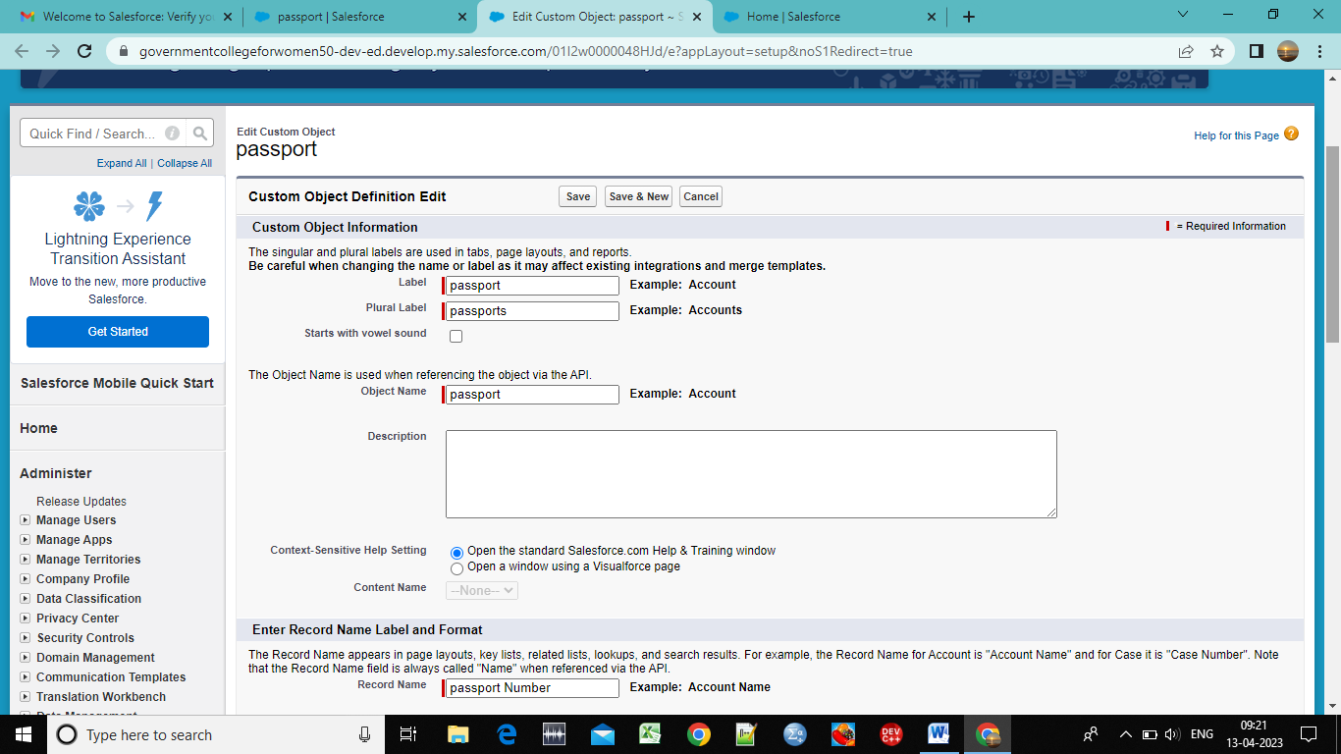

**Creation of fields:**

1. **Click the fields and relationship in the custom object and click new.**
2. **Then select the data type and enter the label name and give length.**
3. **Click the next option and click on visible checkbox and click next.**
4. **Select the pagelayout and save it.**

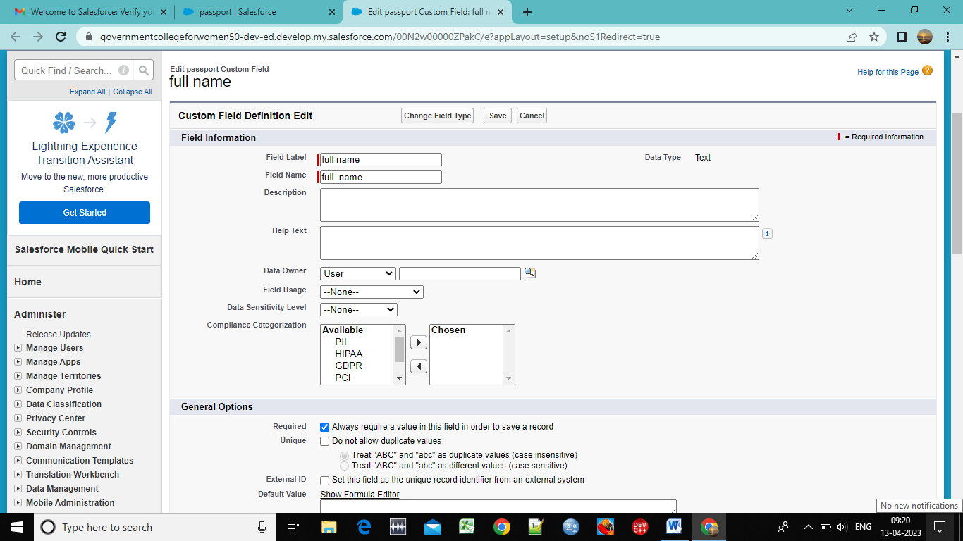

**Creation of Relationship:**

1. **Creation of new object select data type has master detail relationship.**
2. **Select related to the object as passport and click next .**
3. **Then enter the label name and click next and select visible to all profiles and save it.**

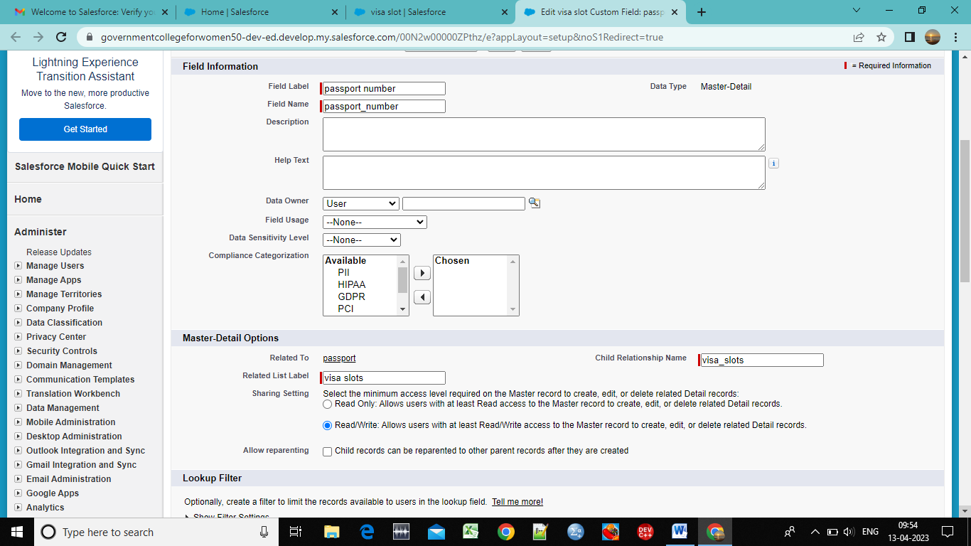

**Creation of app:**

1. **Go to app manager give app name and upload picture click next.**
2. **Move available items to selected items and system admin profile to selected items.**

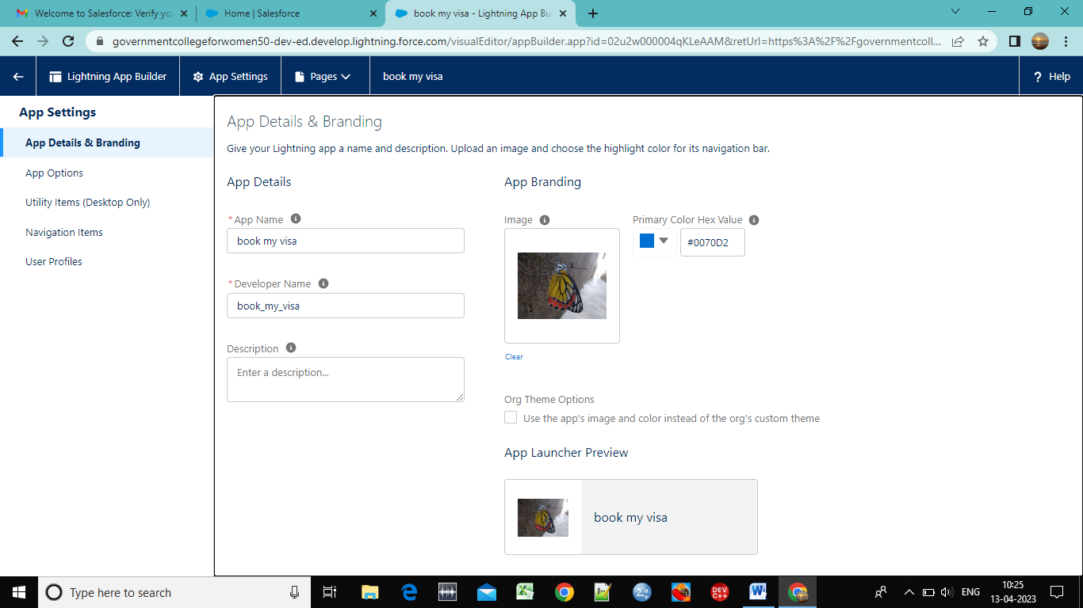

**Creation of user:**

1. **Go to user and click new user.**
2. **Enter name ,email id, user name and in profile select standard user.**
3. **And bottom click the box to generate a password.**

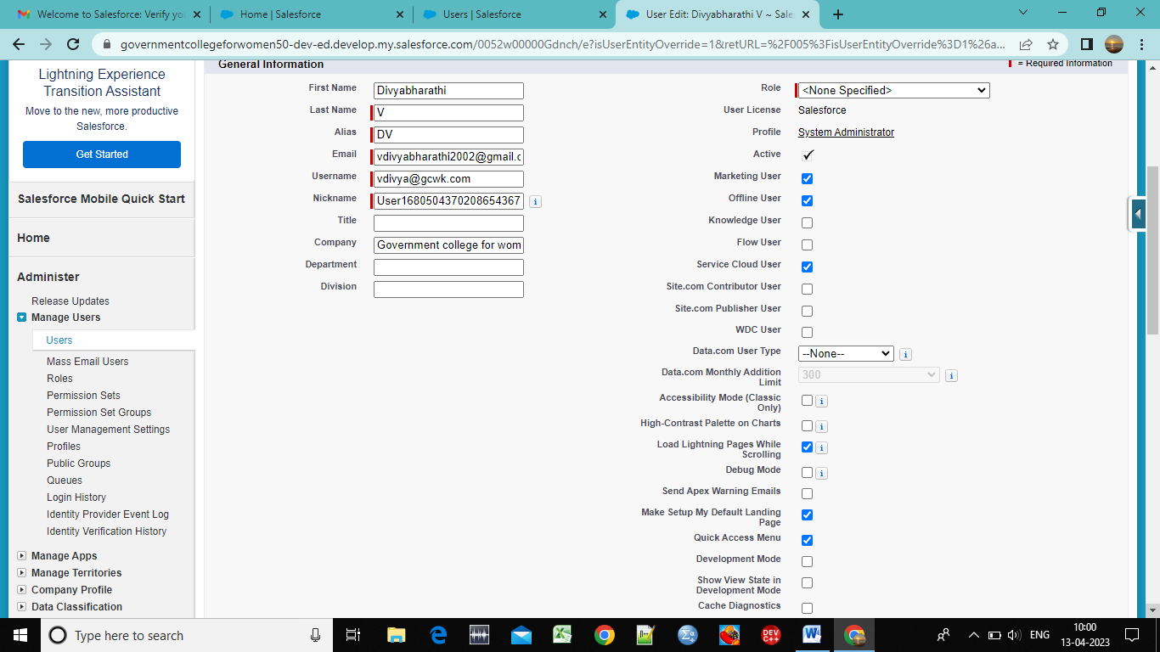

**Creation of report:**

1. **Go to app launcher click on reports. Select a new report.**
2. **Select report type name and click start button .**
3. **Give outline pane and filter and select the objects.**
4. **Click on save and run.**

**Creation of dashboard:**

1. **Go to dashboard click new dashboard and select the report what we are created and select create option.**
2. **Add component and select the donut chart in display as section .**
3. **Leace the default values .click on add and save the dashboard.**

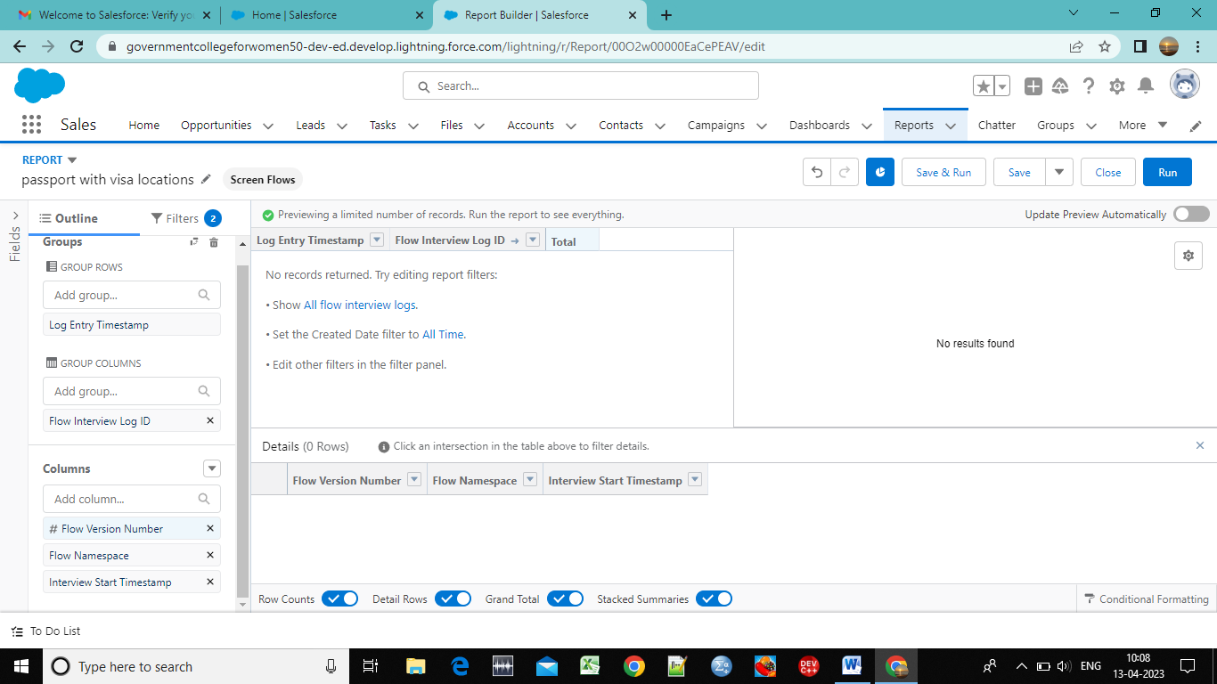

**4.TRAILHEAD PROFILE PUBLIC URL**

Team lead - <https://trailblazer.me/id/divyv25>

Team member 1 -<http://trailblazer.me/id/dsankar23>

Team member 2 – <https://trailblazer.me/id/gperiyasamy3>

**5.ADVANTAGES AND DISADVANTAGES**

* **Stress free and easy payment options.**
* **Improve customer service.**
* **Centralized data makes everything convenient.**
* **Employees training is must.**
* **Having lots of security concerns**
* **It eliminates the human element.**

**6.APPLICATIONS**

* **Which helps to track and manage the availability of visa slots.**
* **It can be used by government agencies to manage appointments of visa.**
* **It can be used by a visa center to schedule appointments with applicants.**

**7.CONCLUSION**

**We were creating a crm that helps to track and manage the availability of visa slots by easy way ,which will be use full for the government and visa booking centers to schedule and manage appointments of visa with the applicants.**

**8.FUTURE SCOPE**

**Over recent decades the immigdration & visa consultation industry has witnessed staggering growth. Given the momentum of people migrating from one country to another, the scope for immigration services is widened expeditiously. Thereby more and more visqa consultancy agencies take birth every day to flood the market and competition rate.**